LAB 3

Nikita Dhingra

# Table of Contents

Table of Contents 2

Lab 3 3

Task 1 – Creation of Bucket and uploading data in S3 3

TASK 2 : Creation of DynamoDB Table and importing from S3 5

TASK 3: Analyse CloudWatch error logs for the failure 8

Task 4 : View the Content of the DyanoDB Table 10

Reflection 11

# Lab 3

## Task 1 – Creation of Bucket and uploading data in S3

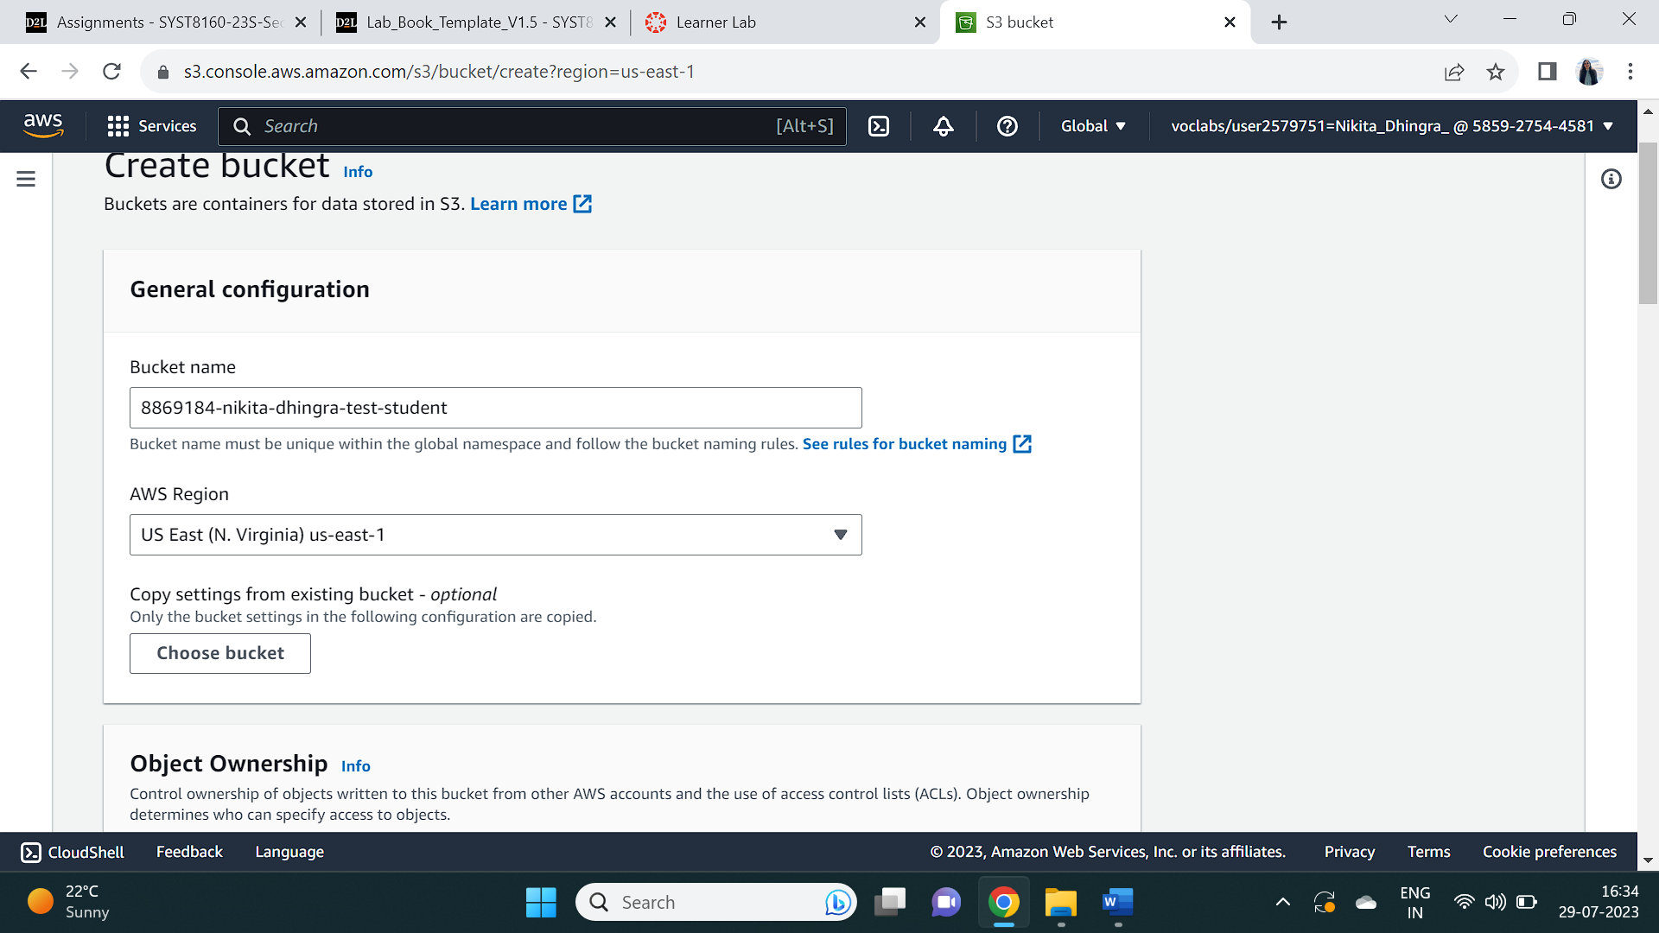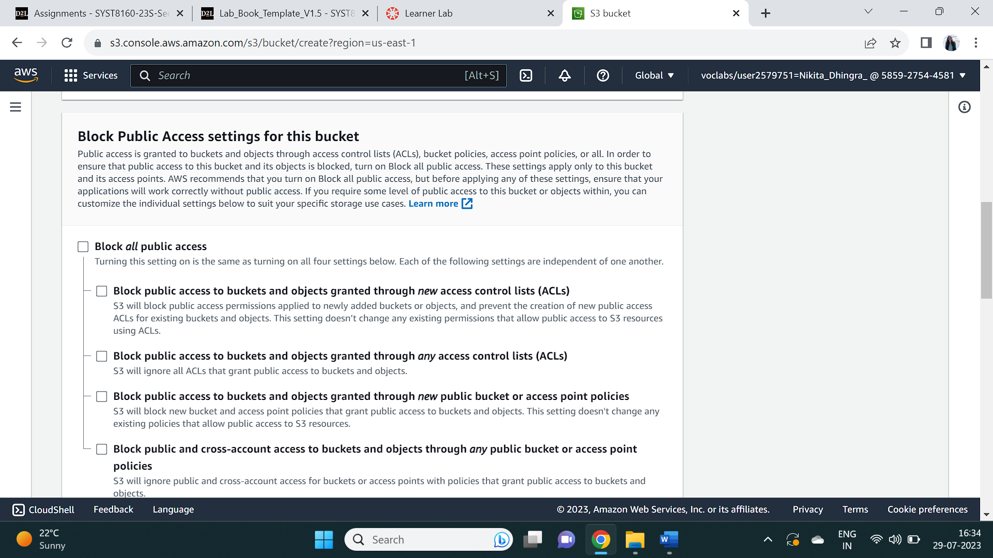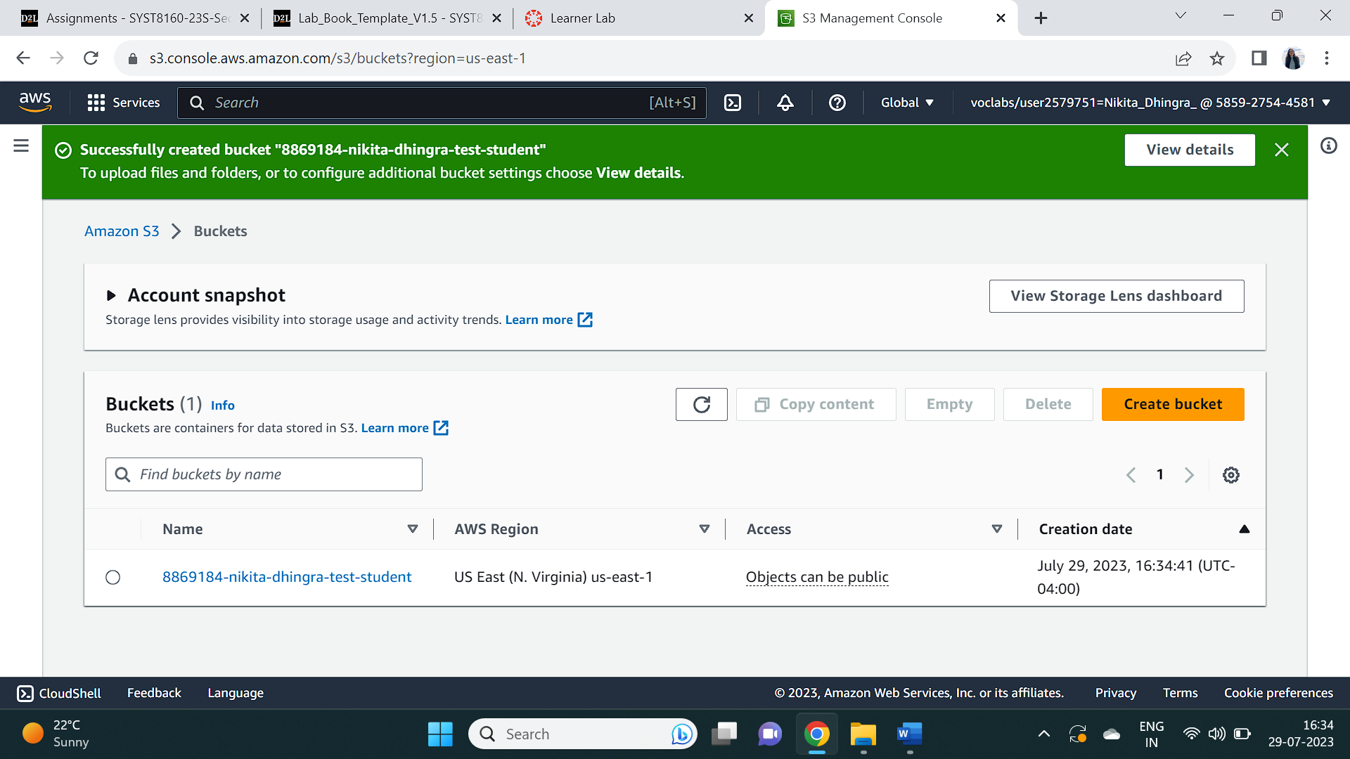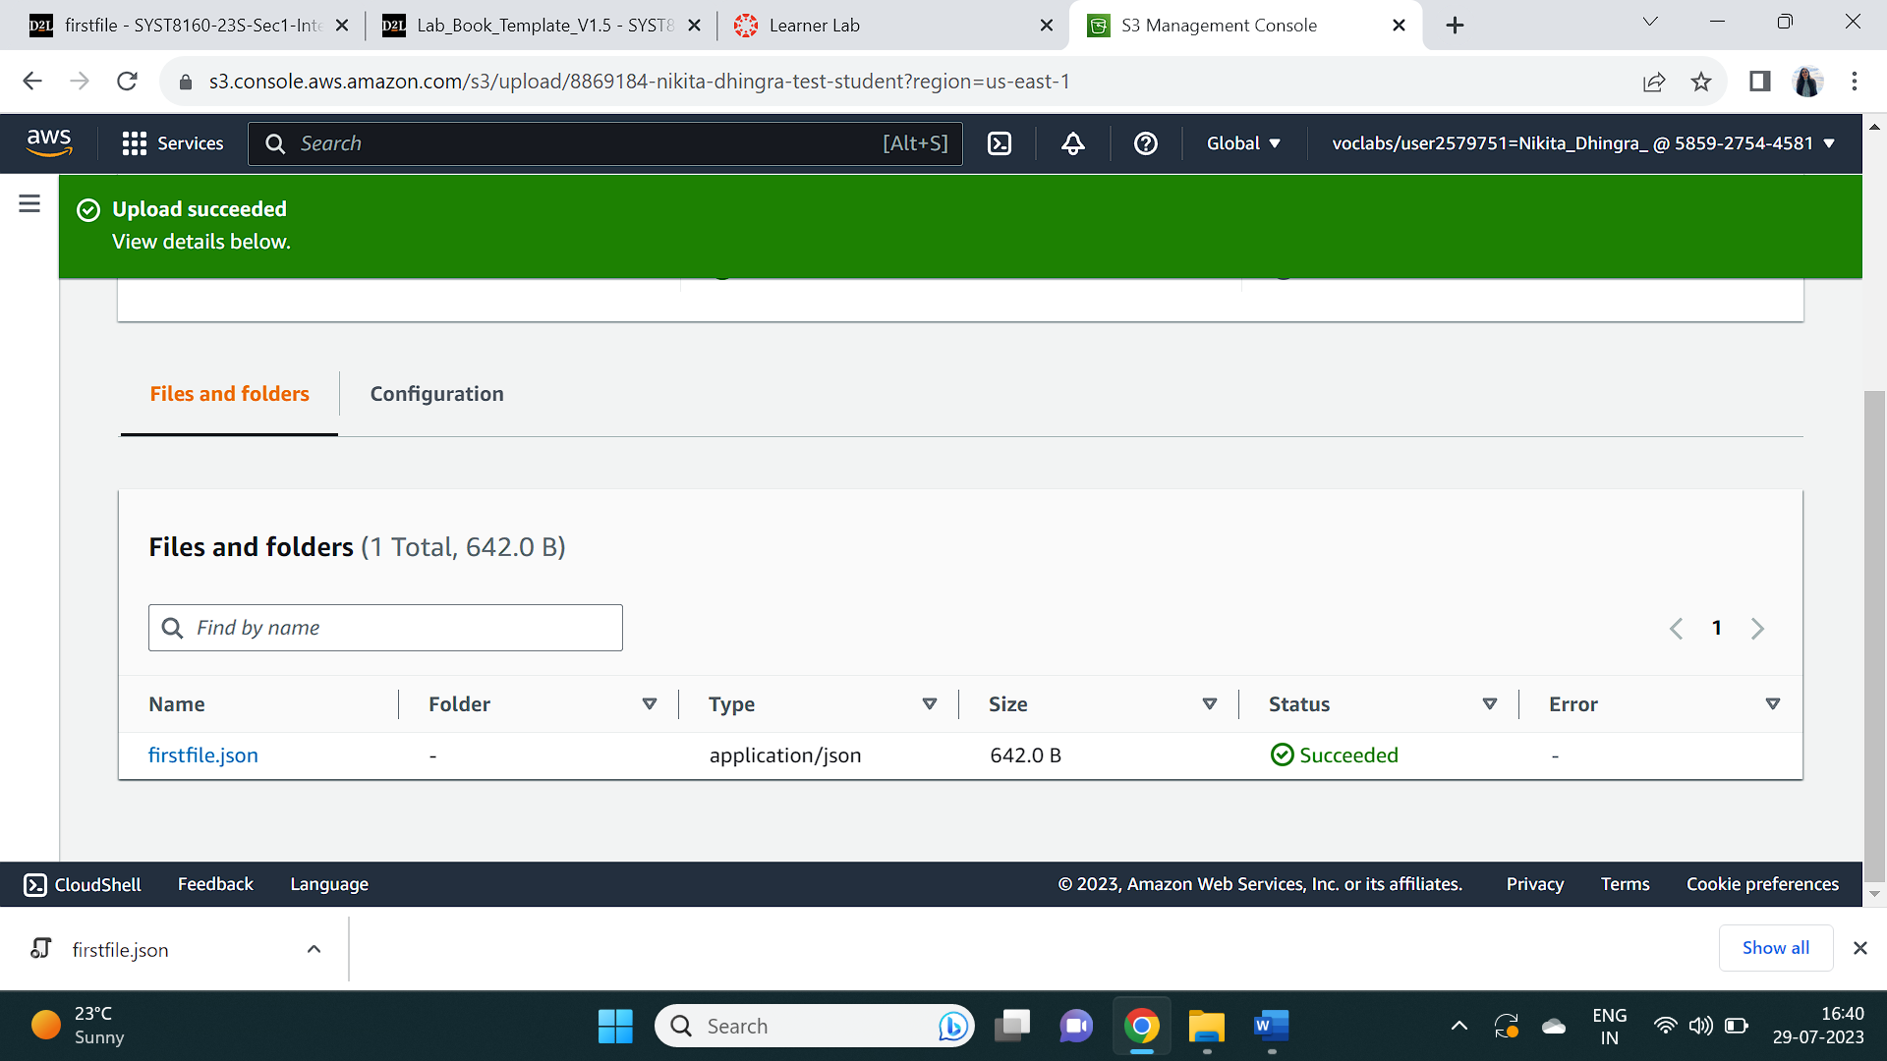

## TASK 2 : Creation of DynamoDB Table and importing from S3

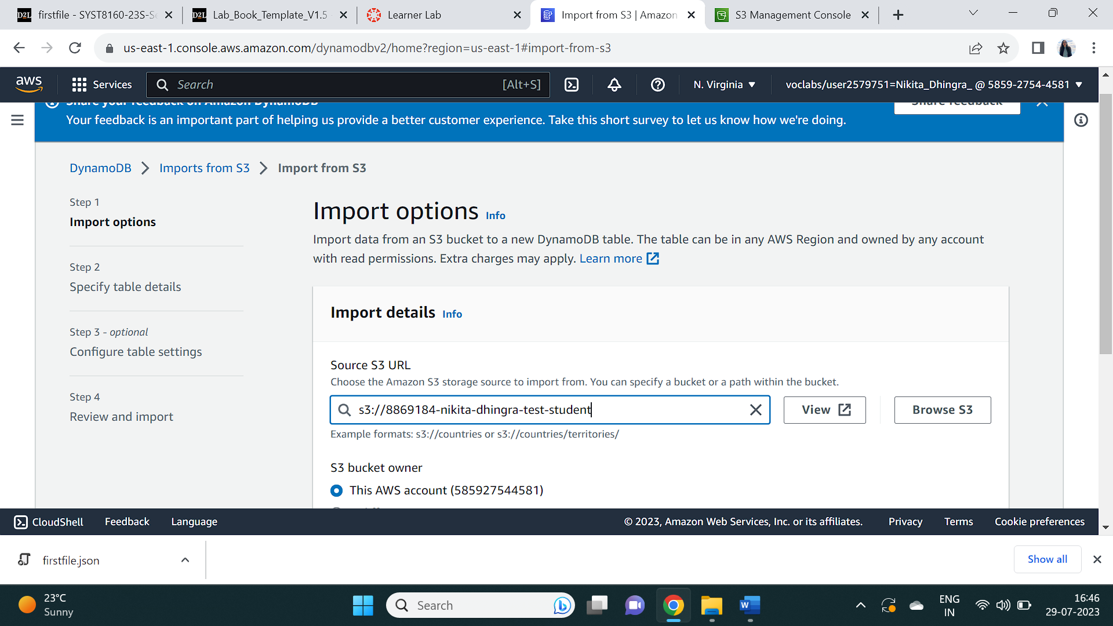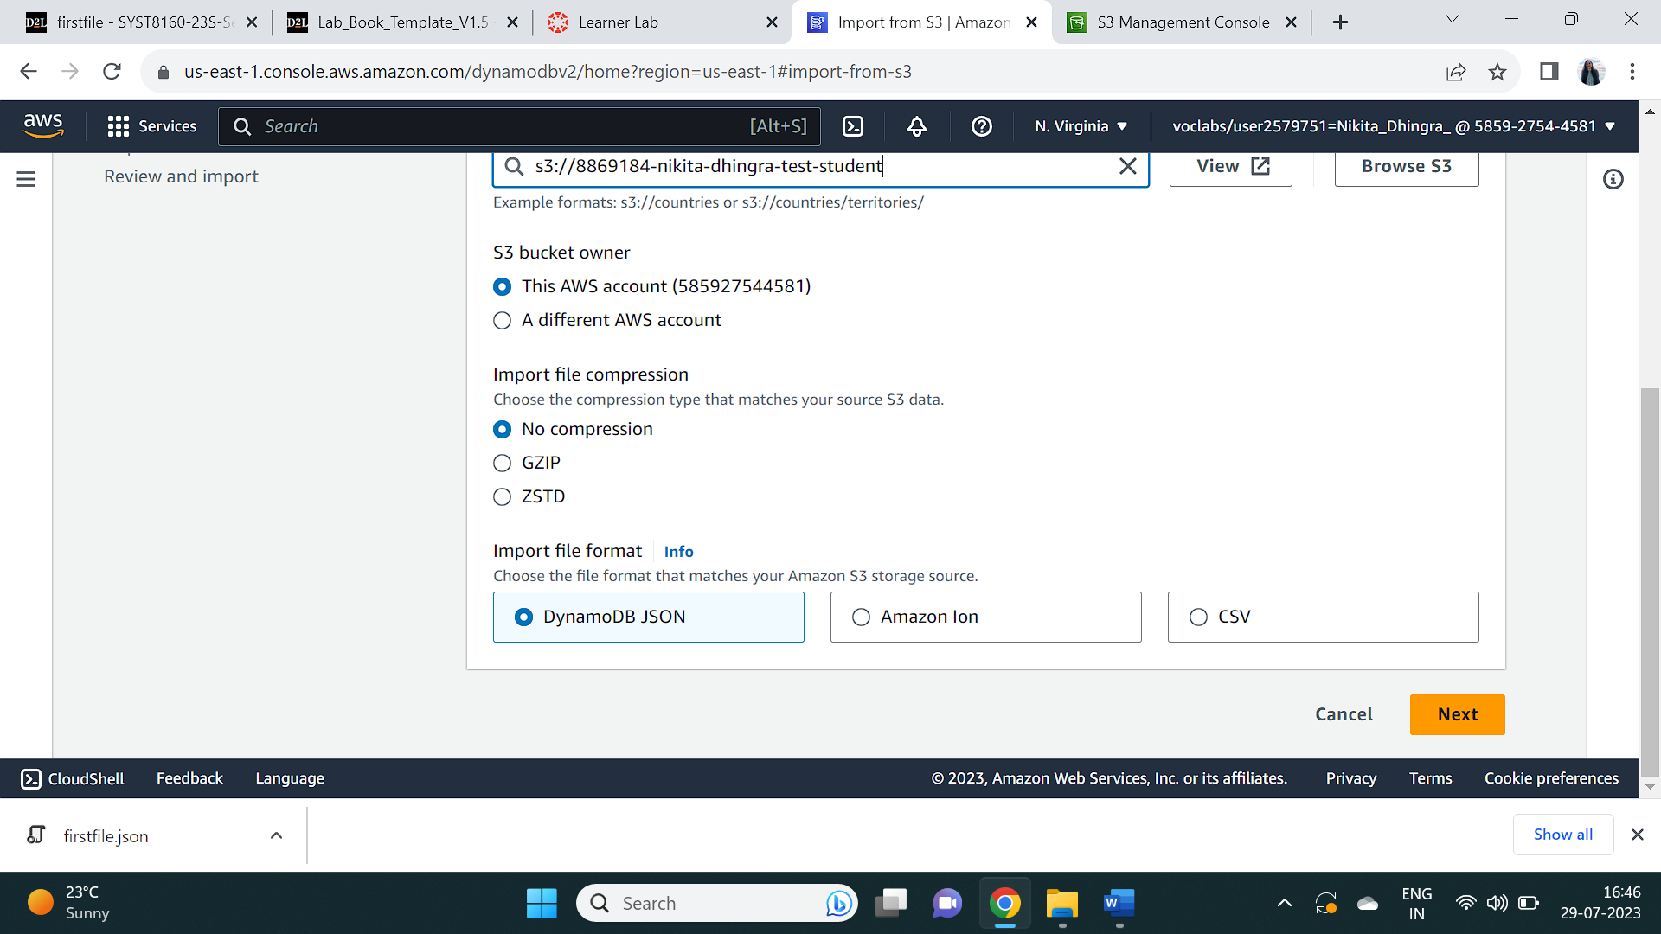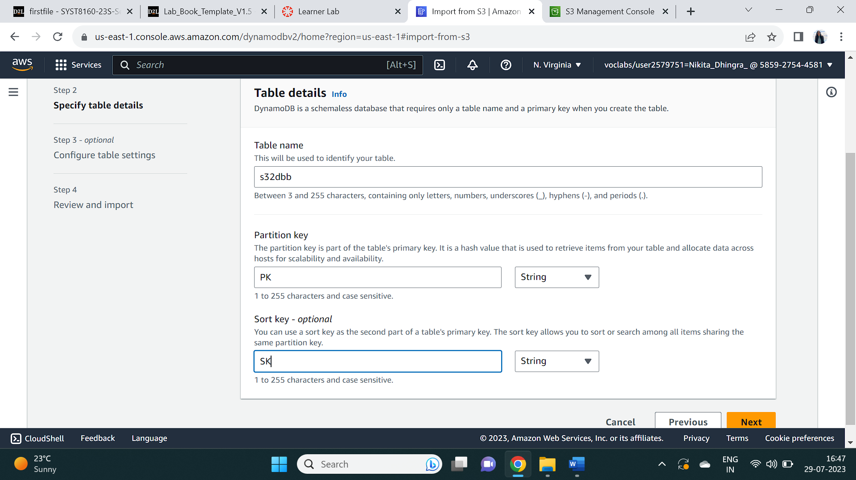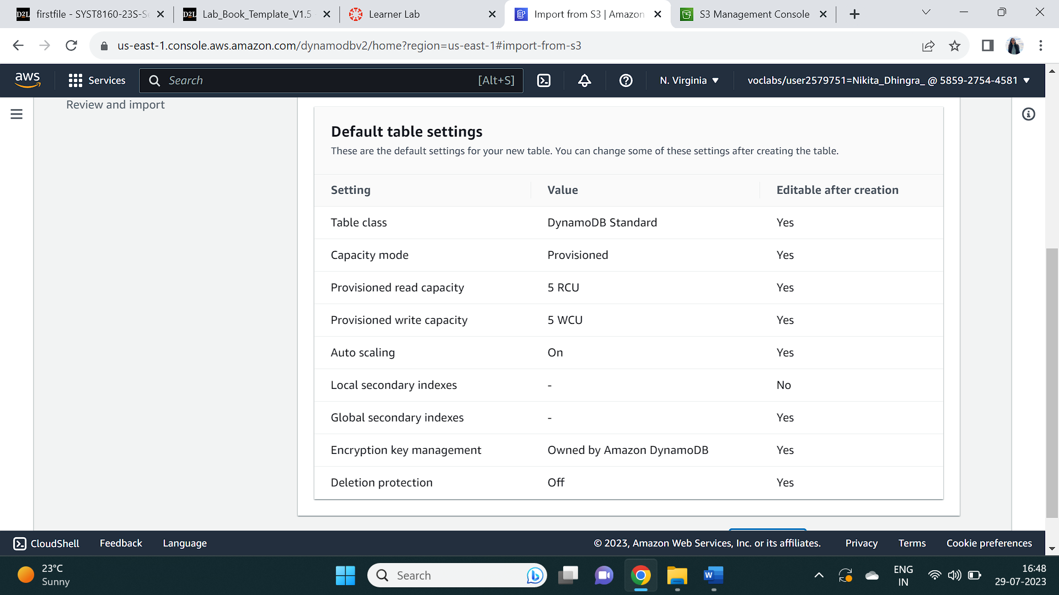

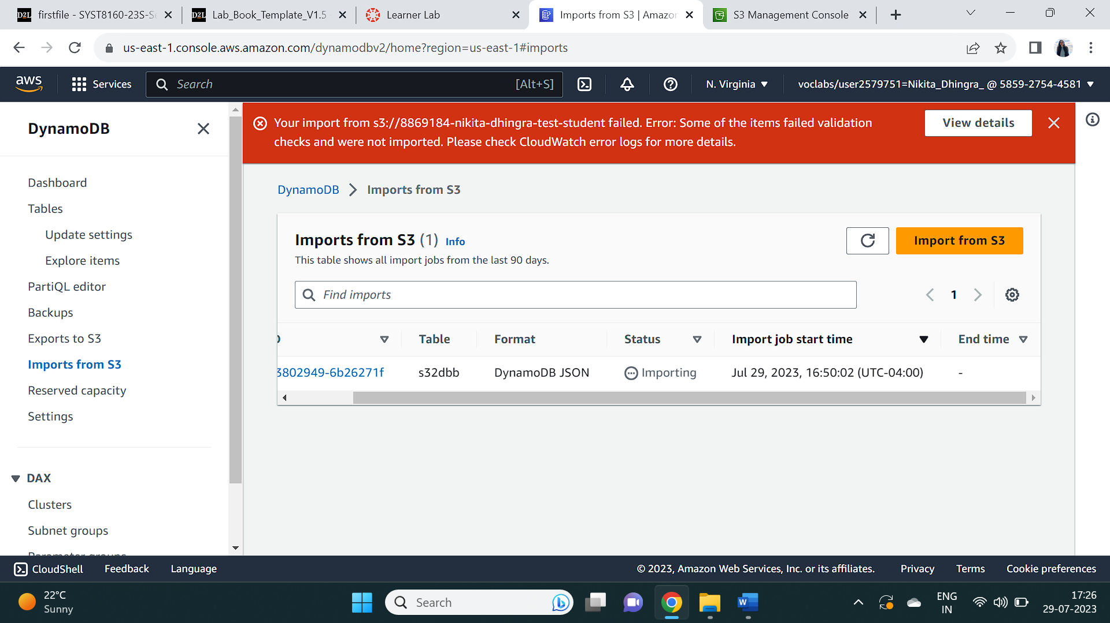

## TASK 3: Analyse CloudWatch error logs for the failure

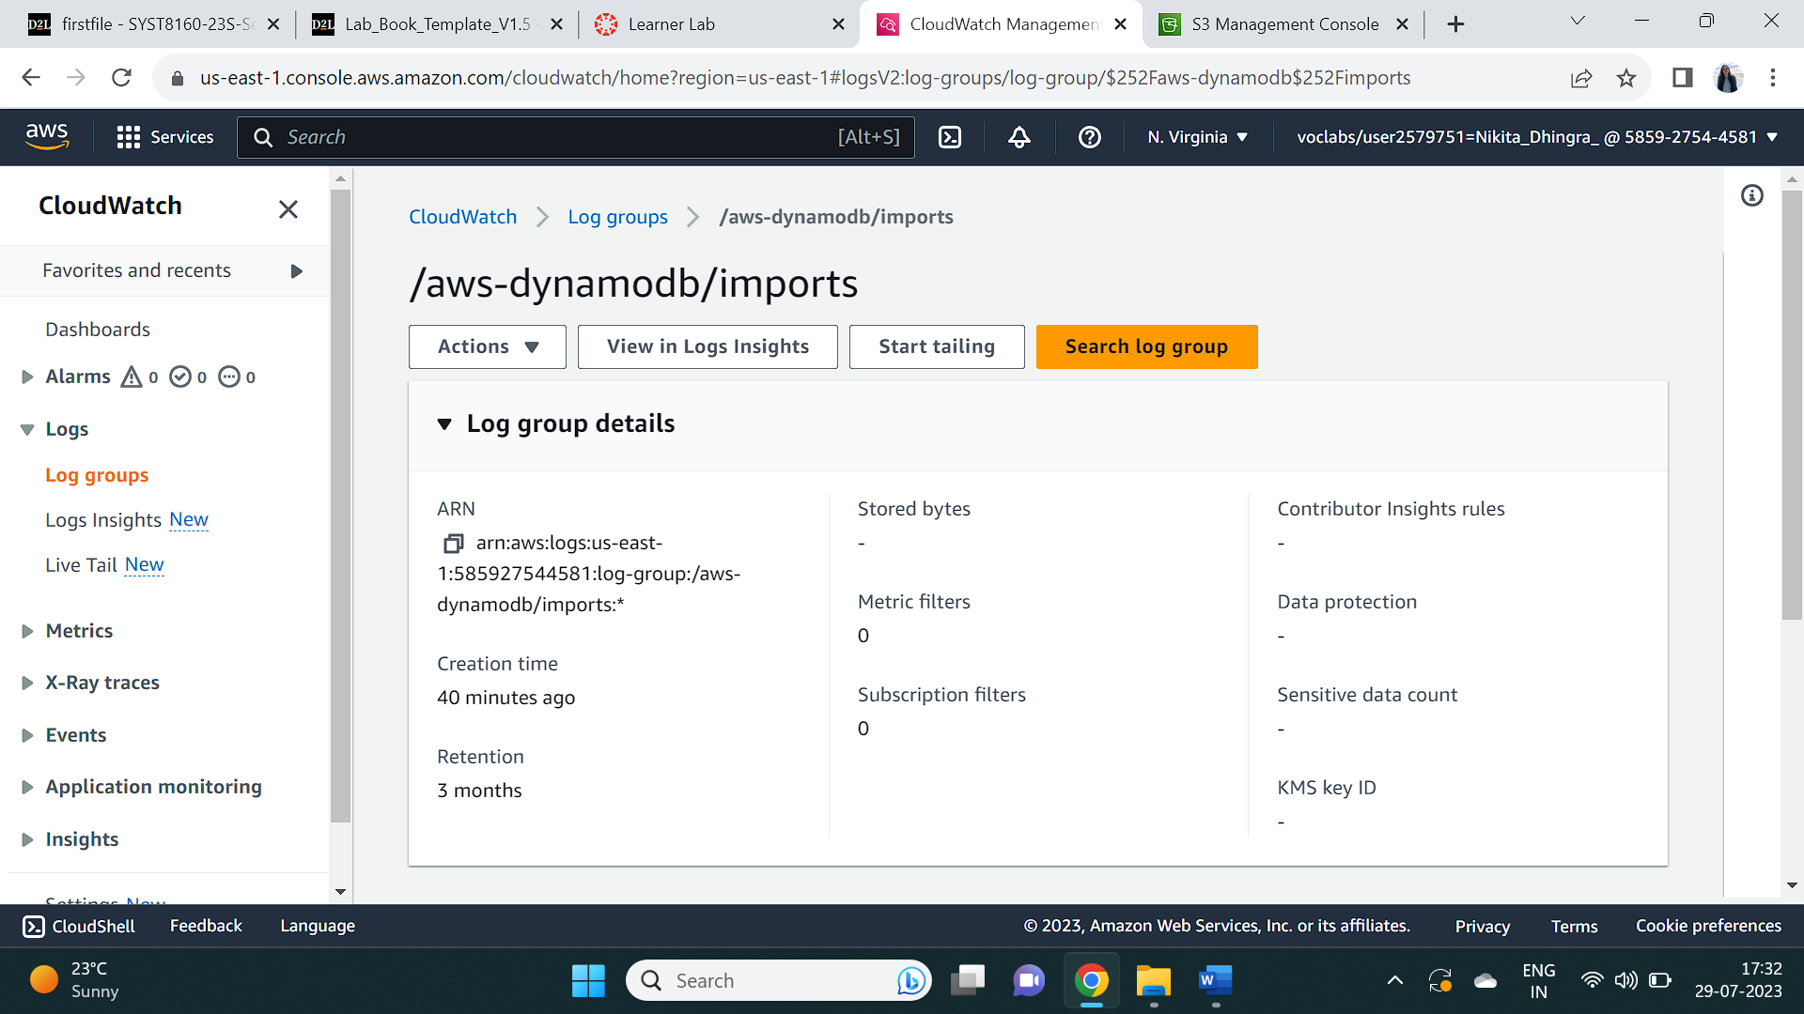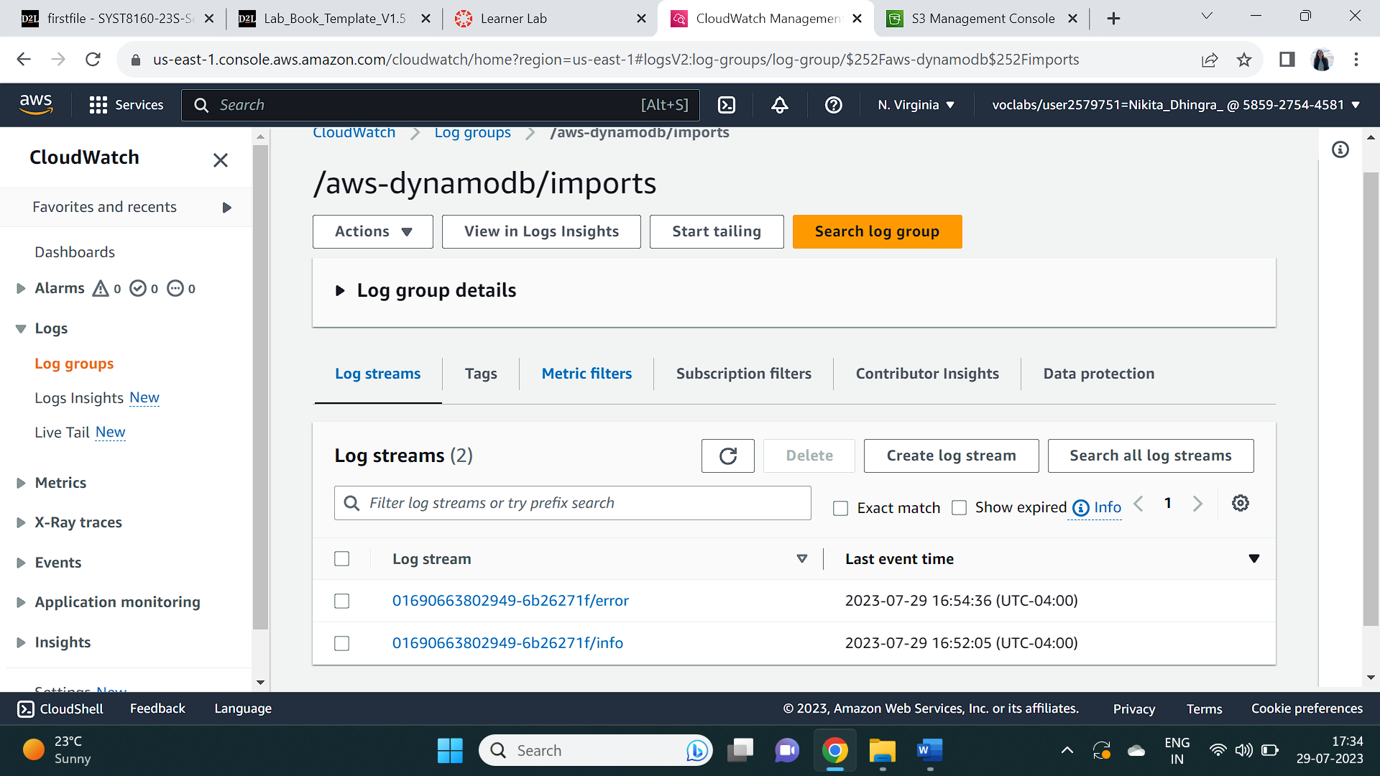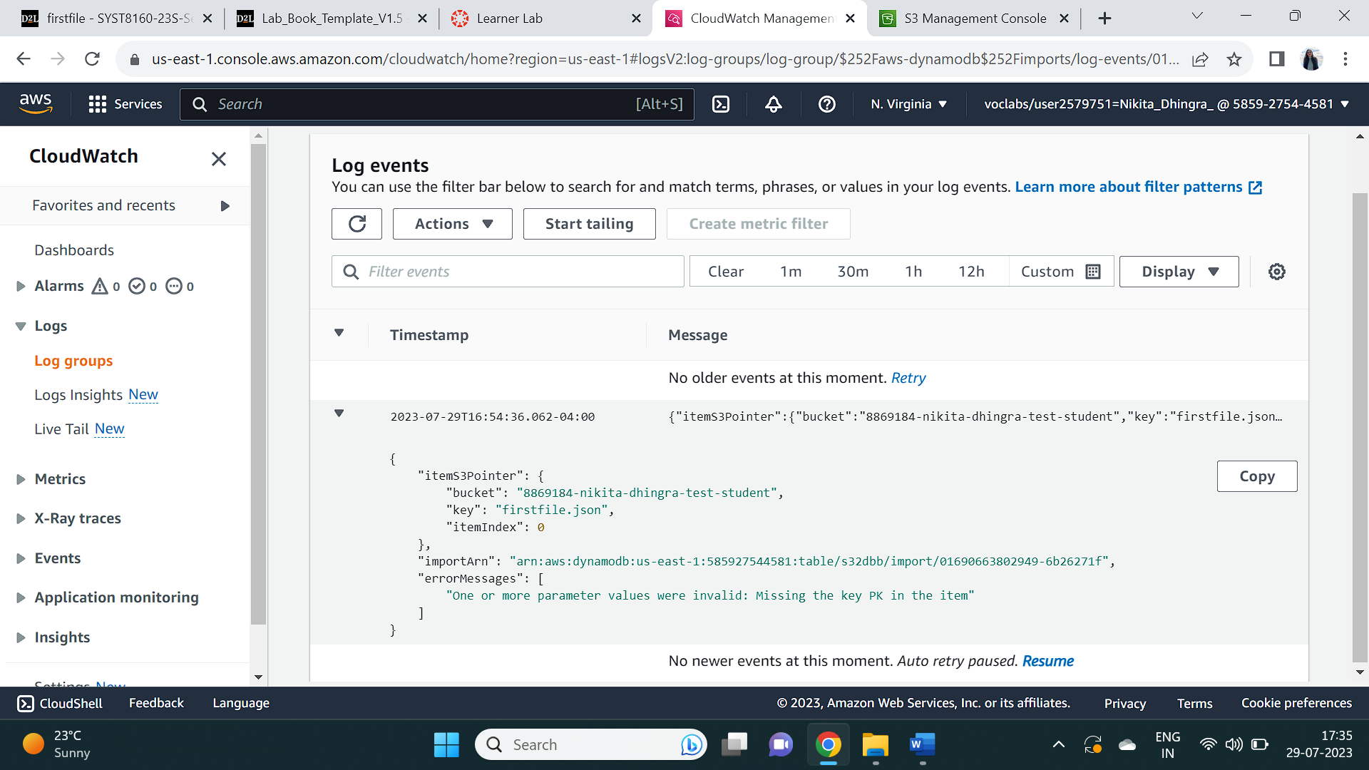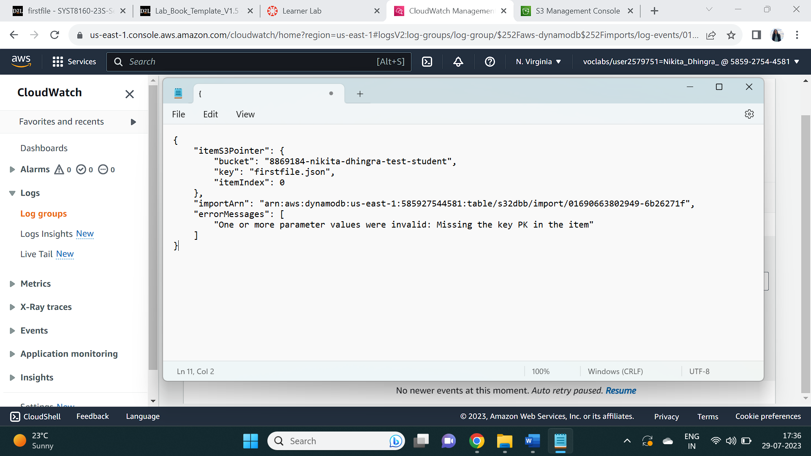

## Task 4 : View the Content of the DynamoDB Table

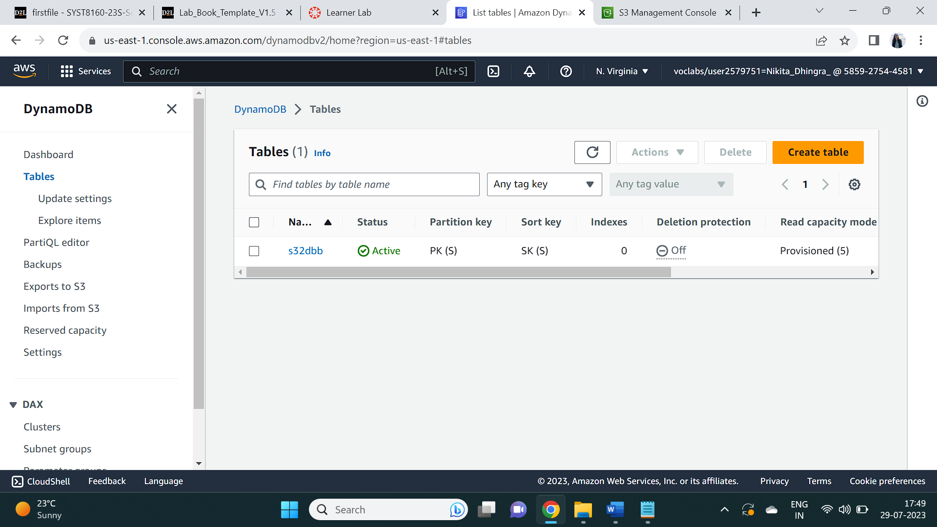

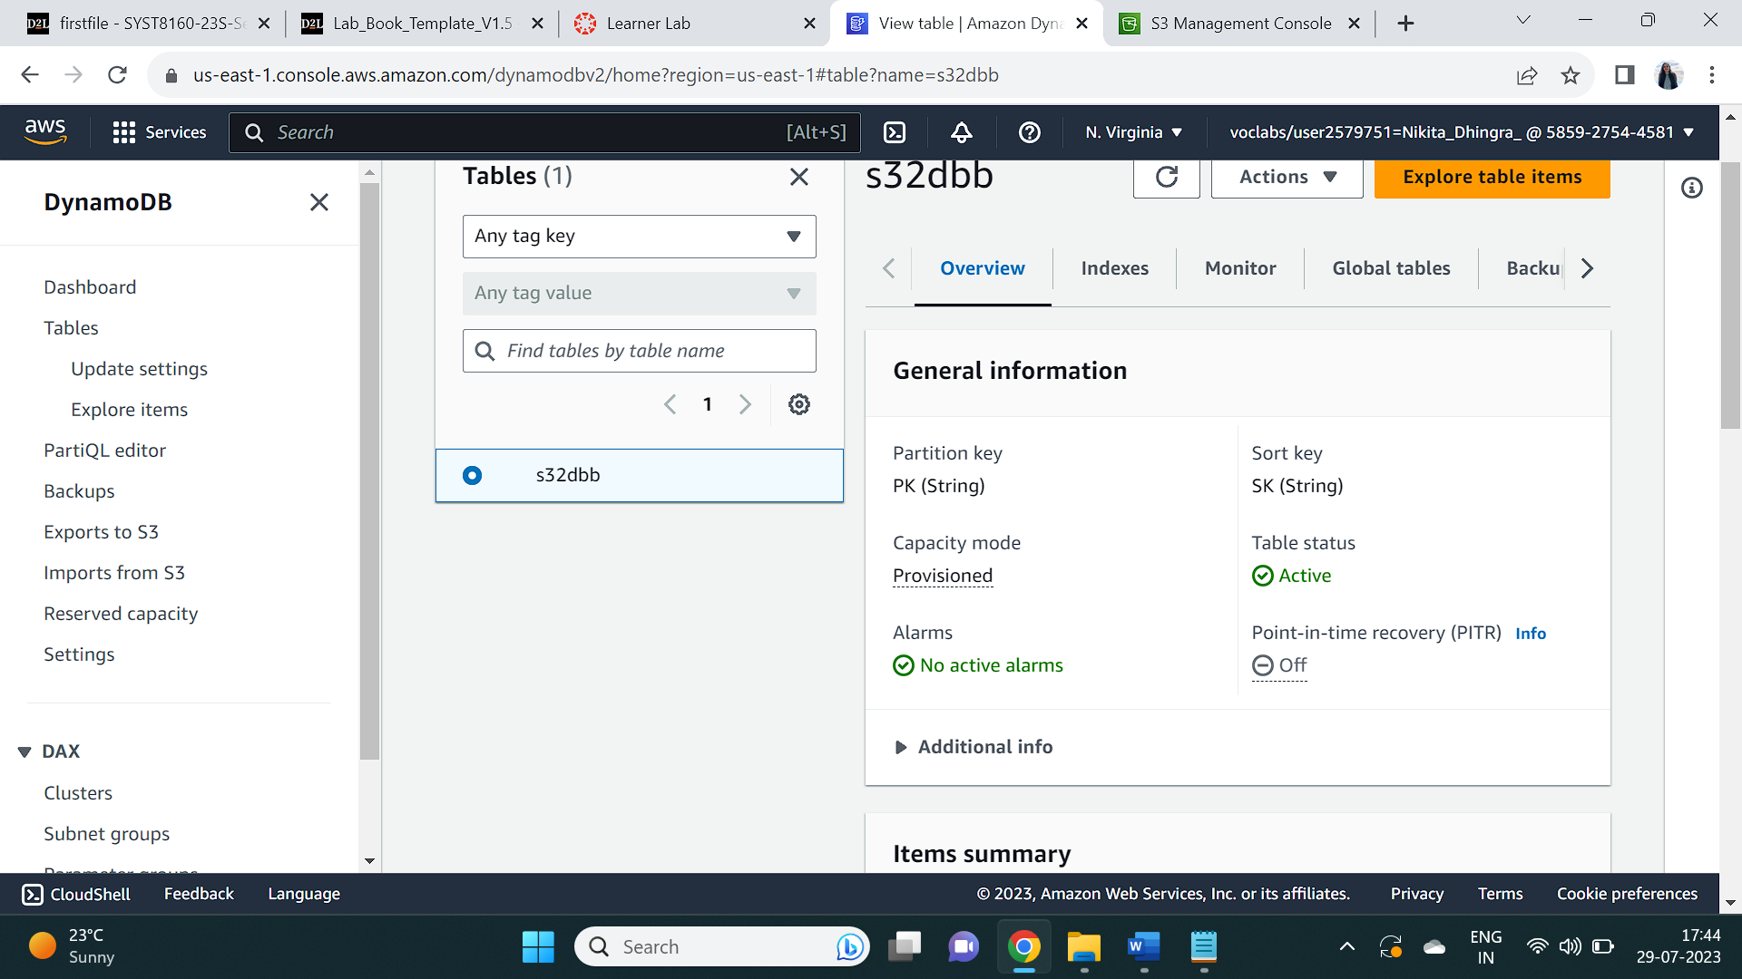

## Reflection

Following questions are addressed below based upon the assignment and the understanding

Q1: Why we need to create S3 Bucket name unique every time? TASK 2

Solution: We need to create and give unique name every single time to the S3 bucket in AWS as to give unique URL to the bucket and uniquely accessible , not combining things which diminishes the chances of errors and have unique work for all in any region and any account.

Q2: What relational Schema DynamoDB table which you created is using? TASK 2

Solution: In contrast to traditional databases, which contain tables with particular columns and relationships, DynamoDB doesn't have any predetermined rules. Instead, DynamoDB operates on items, and each item functions as a distinct record with a unique set of properties. DynamoDB provides two primary keys to efficiently arrange and locate items. Partition key, and it facilitates in distributing data among various storage sources while the other is a sort key which places the elements inside each partition in a particular order. DynamoDB can discover and retrieve the information quickly by combining these keys making it more scalable, flexible and available. Following are the keys used in the lab known as PK and SK.



Q3: Identify that why did you receive those errors? TASK 3

Solution: According to the error message, it does not contain a key called PK (Partition Key) defined , which is required for the operation as for each thing to be processed properly into the database, users must ensure sure that it has a valid and unique Partition Key in order to prevent this issue. The error happens because DynamoDB cannot find the specific item in the table S32dbb.





Q4: Why did you received errors while importing data from S3 Bucket? TASK 4

Solution: Each database object in DynamoDB must be uniquely identified by a primary key (PK in our case) in order to enable quick information retrieval and updates. In the lack of a primary key, DynamoDB cannot determine which item this procedure must be run on, so it throws the error. The key PK not allotted in the item states the absence of the primary key which is required for the operation and processes in DynamoDB database -s32dbb.